**Name :** Dhavalkumar Vijaykumar Patel

**Subject :** Essential of Cyber Security and Cyber Waefare

**Class :** M.Sc Cyber Security

**Semester :** 1

**Lab 9 :**

1. MS Windows security templates

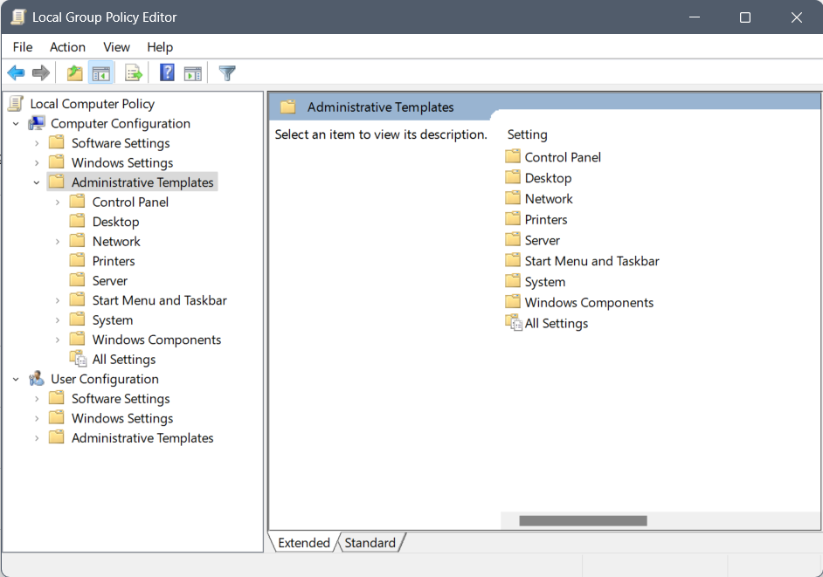

1. NeWT vulnerability scanner

NeWT (Neural Network-based Web Text) is a natural language processing model developed by OpenAI that is capable of understanding and generating text. It is not related to using a vulnerability scanner in Windows.

To use a vulnerability scanner in Windows, you will need to install and run a software program that is specifically designed for this purpose. Some popular vulnerability scanners for Windows include Nessus, Qualys, and Nmap. Once the scanner is installed, you can run it on your system to check for known vulnerabilities and provide recommendations for how to fix them. It's important to note that vulnerability scanners can be resource-intensive and may slow down your system while they are running.